# Trilogy-Film-Project

The Hammered Horror application is a web-based film generator application. During the pandemic people are watching a lot more films. As a team we decided to develop an application based on the Horror genre.

## Minimum Viable Product:

The project utilises the Agile software development lifecycle. This allows the developers to work collaboratively on the development lifecycle, workflow and deployment.

The developers developed initial project initiation concepts based upon the MVP requirements. The ideas evolved and refined after meetings with the tutor and team. The final Hammered Horror film concept was chosen after carefully selecting the API’s.

### Design.

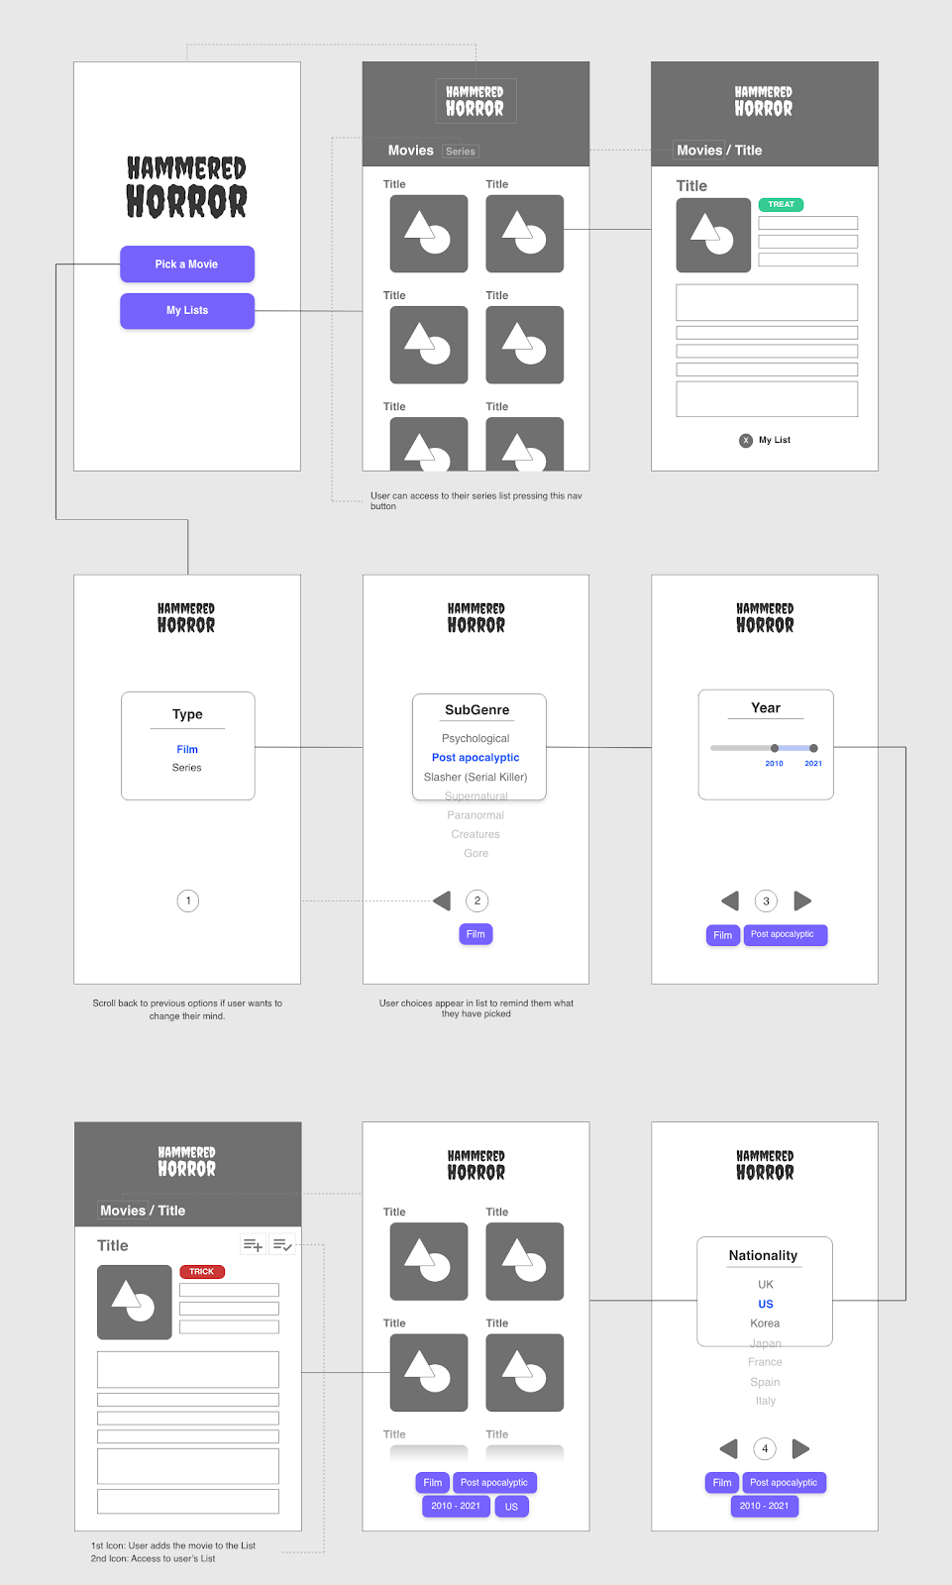

The application was designed using wireframes to show the user making the different selections.

The project uses two CSS frameworks.

Materialize CSS is the bulk of the CSS styling used to define the HTML layout of the pages, selectors and film cards. A second Bulma CSS framework is also used to highlight the forms showing which movies the user has selected.

In order to make the application text appear scary a google creeper font style was used. This was to stylise the main header and titles text. Font awesome was used to highlight the horror icons.

The project is hosted in GitHub:

Git Hub URL

<https://thomwilliams.github.io/trilogy-film-project/index.html>

### Website

The deployed application’s live URL is: <https://thomwilliams.github.io/trilogy-film-project/>

The application can be launched in any mobile or desktop browser.

### Technology

HTML, JavaScript, Server Side APi’s. More description about the app page 3.

The user enters a series of preferences and the application then selects a series of movies for them.

### User Stories

As a <Horror fan> I want an application that only searches Horror movie and TV series

As a <Horror fan> I want to select which type of film I want to watch by sub-genre, nationality and year.

As a <Horror fan> I want to see a list of movies based on these search criteria

As a <Horror fan> I want to see more information about each movie such as the Age certificate, cast, Director, Title and a cover image.

As a <Horror fan> I want a simple way of deciding if the film will be a treat (recommended viewing), a trick (not highly rated) or a jury’s out (undecided rating).

As a <Horror fan> I want to see a notification (Not enough Data) if my selected choices show no results.

As a <Horror fan> I want to be able to save my preferred choices so that I can view them later.

### Technology used.

The application uses HTML and two CSS styling frameworks to stylise the selector screens.

Two Server side API’s:

-**THE MOVIE DB** - to access general data on a wide range of horror films and shows, plus subgenre/keyword and language reference data necessary for defining the user selection.  
  
- **OMDB (The Open Movie Database**) - to cross reference collective critical scores from three different databases (Rotten Tomatoes, IMDB and Metacritic) which were essential to the “Trick” Or “Treat” functionality.

JavaScript.

JavaScript files are used to call The Movie DB API and then display the data for the user’s selections. The OMDB API is called and the data for the final movie is selected. JavaScript code is used to navigate between the different selector pages for the user and dynamically link the HTML and CSS. This creates a polished responsive user interface for the client.

The user’s selections are then saved on the browser in local storage (client storage).

Git Hub.

Git hub was used as the repository to store, control, create branches and resolve code conflicts with the development team.

### Screen shots.

Home screen

The user is presented with the home screen and is able to make their movie and TV series selections.

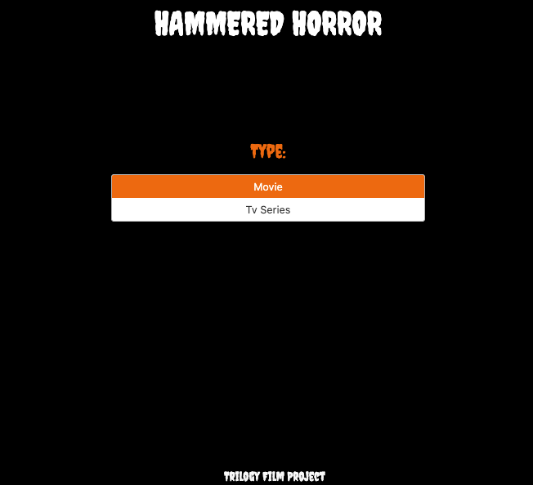

Sub-genre.

The user can select the different type of Horror Films for example Psychological, Slasher etc

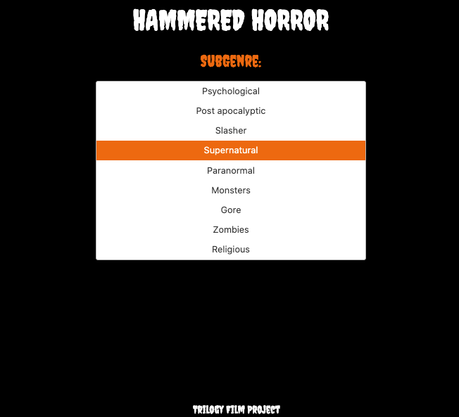

Year.

The user can select the year of the title.

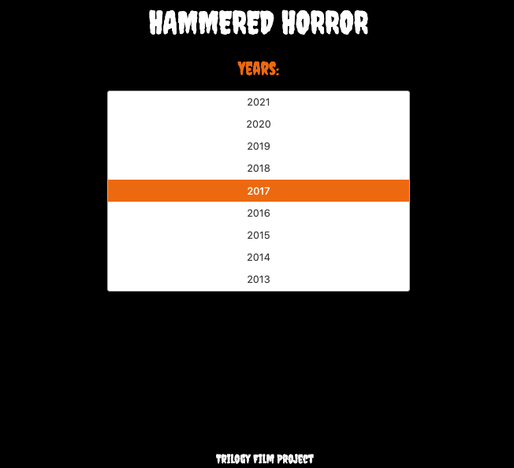

Card Selector

The user can then see a list of movies they can click and select.

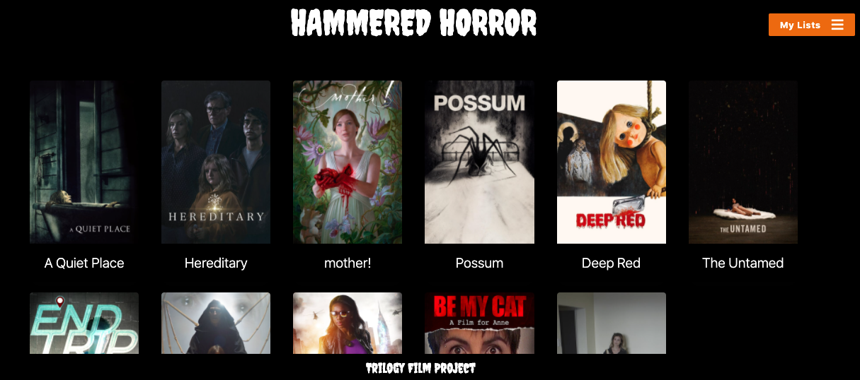

Movie Card list

The user can click and select the individual card details and view the film cover, cast, director etc. Also, the API’s check the ratings and provide the user with a recommendation if the film is a trick or treat.

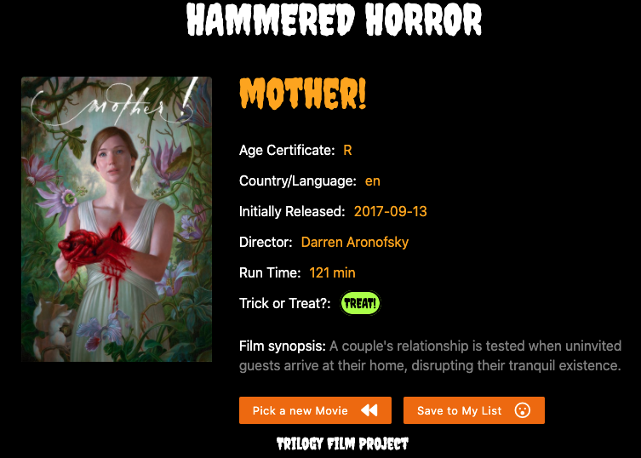

Local storage.

The user can then click on my list and view a saved copy of their films.

### Areas for future development.

* Tell users where they can watch the selected title e.g., Netflix, Amazon (which will require further API’s such as [GoWatchIt](https://public-apis.io/go-watch-it-api))
* Additional selectors to help users find the perfect movie e.g., awards a movie has won, select a range a year as opposed to just a single year.
* Include additional interactive content e.g., trailers.
* Find ways to eradicate any discrepancies in the data provided (e.g., if name of director is not provided by the API).
* Further development of “Trick” Or “Treat” rating rules and data comparisons.
* Fright factor rating - a scale of how scary a film / series

Accessibility

WAVE

The application has been through a WAVE accessibility checker to ensure it conforms to accessibility requirements for disabled users.

<https://wave.webaim.org/report#/https://thomwilliams.github.io/trilogy-film-project/index.html>

The results

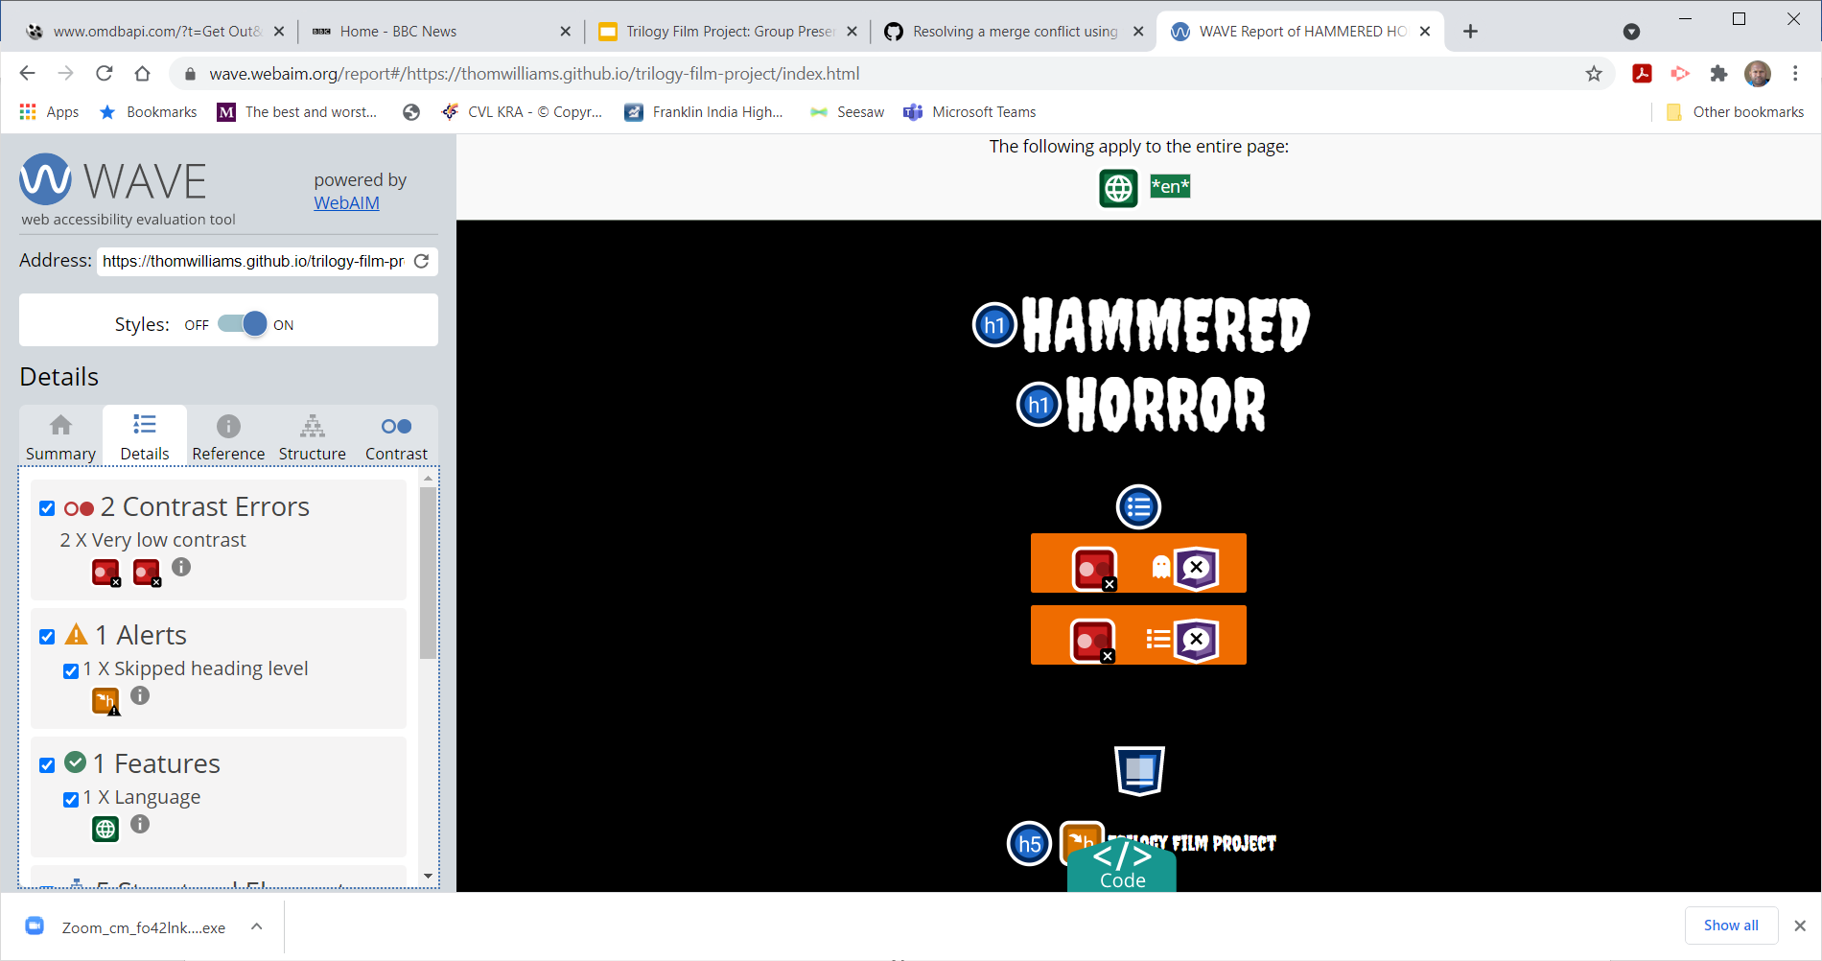

References:

Agile Software development:

Git hub

Git hub branching:

<https://git-scm.com/book/en/v2/Git-Branching-Branching-Workflows>

Git Tutorial:

<https://www.learnenough.com/git-tutorial/getting_started>

Git Merge conflicts:

<https://docs.github.com/en/github/collaborating-with-issues-and-pull-requests/resolving-a-merge-conflict-using-the-command-line>

Bulma

https://bulma.io/

Materialize

https://materializecss.com/getting-started.html

Stack Overflow

https://stackoverflow.com/

OMDB

http://www.omdbapi.com/

The Movie Database

<https://www.themoviedb.org/?language=en-GB>

WAVE

https://wave.webaim.org/